*Assignment on Humanities-II: Organizational Behaiviour :*

Name: Bhabajyoti Borah

Roll No: 200102017 Branch: IT

Subject Code: HS-311

Subject Name: Humanities-II:

Organizationtal Behaviour

QUESTION NO. (1):Sexual harassment at workplace...explain with an example?

ANS:

Sexual harassment is a type of harassment involving the use of explicit or implicit sexual overtones, including unwelcome and inappropriate promises of rewards in exchange for sexual favors. Sexual harassment includes a range of actions from verbal transgressions to sexual abuse Harassment can occur in many different social settings such as the workplace, the home, school, churches, etc. Non-verbal gestures and behavior can cross the line of professional conduct into sexual harassment. Generally, any nonverbal behavior seen as being sexual in nature can result in sexual harassment of a co-worker that makes them feel uncomfortable.

Examples of Sexual Harassment at the workplace:

(1) Physically blocking a person’s movements; in other words – standing in their way

(2) ‘Accidentally on purpose brushing up against a person

(3) Staring or looking their body up and down

(4) Following them around or paying excessive attention

(5) Making insulting comments about someone’s gender identity or sexual

orientation or asking about someone’s sexual orientation

(6) Telling lewd jokes or sharing stories about sexual experiences – even if this is not

directed at you but done in your presence to cause you discomfort

(7) Sending unwanted suggestive or lewd emails, letters or other communications or

sharing images of a sexual nature around the workplace or displaying posters,

items or screensavers of a sexual nature

(8) Inappropriate and suggestive touching, kissing, rubbing or caressing of a

person’s body and/or clothing

(9) Repeatedly asking for dates despite being rebuffed or asking for sexual favors

(10) Making sexually offensive gestures, remarks or facial expressions

QUESTION NO. (2): Explain negotiation process?

ANS:

Negotiation is a dialogue between two or more people or parties to reach the desired outcome regarding one or more issues of conflict. It is an interaction between entities who aspire to agree on matters of mutual interest. The agreement can be beneficial for all or some of the parties involved. The negotiators should establish their own needs and wants while also seeking to understand the wants and needs of others involved to increase their chances of closing deals, avoiding conflicts, forming relationships with other parties, or maximizing mutual gains.

The stages in the process of negotiation includes :

(1) Preparation and planning

(2) definitions of ground rules

(3) clarification and justification

(4) Bargaining and problem solving

(5) closure and implementation

Below is the diagram of the stages of negotiation process:

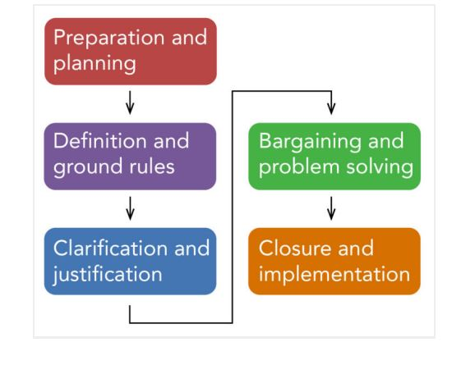

QUESTION NO. (3): Write a note on Gender bias?

ANS:

Gender bias is behavior that shows favoritism toward one gender over another. Most often, gender bias is the act of favoring men and/or boys over women and/or girls. However, this is not always the case. In order to define gender bias completely, we first must make a distinction between the terms gender and sex. When we use the term gender, we mean socially constructed expectations and roles for women and men, for girls and boys. Specifically, girls and women are expected to demonstrate feminine behavior, and boys and men are expected to act masculine. By sex, we mean biological differences assigned to females and males in order to distinguish between the two. The biological characteristics assigned to females and males often consist of primary or secondary sex characteristics. The term gender bias is often used interchangeably with the term sexism. Sexism is typically defined as the subordination of one sex, usually female, based on the assumed superiority of the other sex or an ideology that defines females as different from and inferior to males.

Gender bias is the tendency to prefer one gender over another. It is a form of unconscious bias, or implicit bias, which occurs when one individual unconsciously attributes certain attitudes and stereotypes to another person or group of people. These biases can affect how the individual understands and engages with others.

In today’s society, gender bias is often used to refer to the preferential treatment men receive — specifically white, heterosexual males. It’s often labeled as sexism and describes the prejudice against women solely on the basis of their sex. Gender bias is most prominently visible within professional settings.

Another term often used interchangeably with gender bias is gender discrimination, which is the unequal treatment of a person or group of people because of gender-based prejudice.

QUESTION NO. (4): Explain Bargaining with an example?

ANS:

Bargaining:

An agreement between parties settling what each gives or receives in a

transaction between them or what course of action or policy each pursues with respect to the other.

Bargaining is a process of reaching a mutually acceptable solution among all parties to the conflict at the end of the negotiation process.

Bargaining strategies help to resolve the conflict through proper

communication and understanding of the situation.

Two types of bargaining strategies are:

(i) Distributive Bargaining:

Distributive bargaining is a competitive bargaining strategy in which

one party gains only if the other party loses something. It is used as a

negotiation strategy to distribute fixed resources such as money,

resources, assets, etc. between both parties.

example:

(1) Market share - While competition exists in the market, there are given products with only a few companies dominating the market share. In this situation, the business carried out is only win-lose because the top companies are gaining the most profits, and hundreds lose the competition and may close business or be bought out.

(2) Car purchase-A man sees an advert for someone selling their used car at $5,000 and is willing to buy it if the seller chooses to sell it at $4,000. If the seller decides to sell the car at $4,000, it will be a loss of $1,000 and a win of $1,000 to the buyer.

(ii) Integrative Bargaining:

Integrative or "interest-based" bargaining is a form of negotiation in which each party attempts to understand the other's interests, on the expectation that it will achieve a better result by helping the opponent create a solution it sees as responsive to its own concerns.

example:

The classic example involves two teenagers and an orange. If there's only one orange in the refrigerator and both teenagers demand it simultaneously, a distributive bargain might well involve each of them getting half of it. In an integrative approach, each might ask the other why he or she wanted the orange,discovering in the process that one wanted to eat the inside while the other wanted the peel to bake a cake. The integrative bargain is obviously better for both.